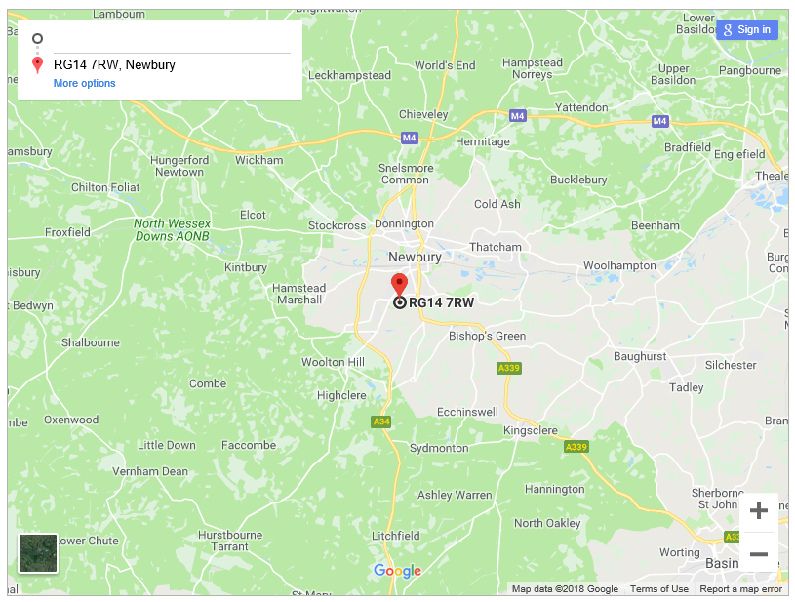

**Free parking facility at Newbury Rugby Club, Monks Lane, Wash Common, West Berkshire, RG14 7RW**

